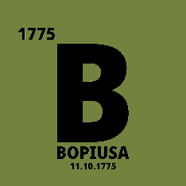
FOR IMMEDIATE RELEASE: JANUARY 24TH, 2020

Veteran-Owned BOPIUSA Launches Patriotic-Themed MORNING REVEILLE Coffee

In today’s retail world, where hundreds of variations of a single product can line store shelves, product oversaturation can make it difficult to decipher which items will stand out as “the best of the best”, satisfying multiple consumer needs such as convenience, health benefits, value, flavor and niche identity.
To best satisfy the bulk of these consumer demands, BOPIUSA, a veteran-owned retailer based out of Minneapolis, has released MORNING REVEILLE COFFEE, an Award-winning, small batch-roasted blend that has immediately sparked interest across the food & beverage world.
BOPIUSA’s Founder & Chief Marketing Officer, Jay Joseph, says the concept was pitched to six different coffee roasters over the last year. “There wasn’t a single coffee executive I spoke to who didn’t convey how great of a brand name ‘Morning Reveille’ was for a coffee product. Across the global military community, that term signals the beginning of a new day, to get started and get moving, which is the very mindset that most people have in the morning when they’re about to make their coffee.”
Joseph added, “It’s nice to be the one with the fitting product name, but then I tossed in all of the other unique aspects I wanted which would make this coffee stand out, such as a premium bean, having it roasted in small batches, making the label patriotic themed and also giving a percentage of the profits to various charitable organizations.”
In the end, it was Iowa-based Smokey Row Coffee Company that jumped at the opportunity, whose stellar reputation as a small business won over Joseph. He states, “It’s satisfying to know that this product concept is still sitting on the desks of the teams from Starbucks and Black Rifle Coffee Company, but it ended up in the hands of a smaller, award-winning roaster right in the middle of our country. Smokey Row is as on point as any other conglomerate, but with an eagerness to deliver stellar quality. Their entire team is just outstanding.”
Currently, Morning Reveille is only available by the case, which contains twelve (12) eye-catching bags of ground coffee. MSRP is $12.00-$14.00/bag. Until major foodservice distributors such as KeHE and US Foods finalize approval for placement onto store shelves across the United States, and as BOPIUSA continues to procure specialty retailers and other clients, buyers can purchase Morning Reveille directly by visiting www.bopiUSA.com.

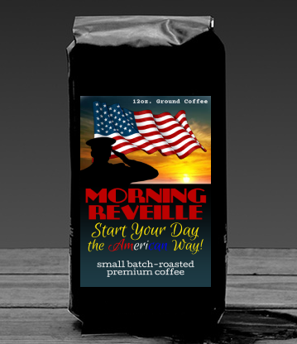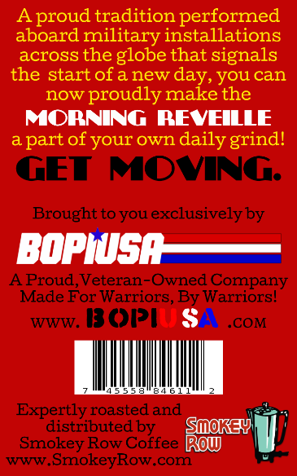
Morning Reveille Coffee (12.oz) Back Label

